Program 7

7. Create menu in Application

1. Click New Project, the New Project Dialog box appears.

2. Choose Empty Views Activity then click Next.

3. Specify the Name of your project, Select the Language as Java, and Select the

Minimum SDK

4. Update the following code in MainActivity.java

package com.example.labseven;  
  
import android.os.Bundle;  
import android.view.Menu;  
import android.view.MenuInflater;  
import android.view.MenuItem;  
import android.widget.Toast;  
  
import androidx.activity.EdgeToEdge;  
import androidx.annotation.NonNull;  
import androidx.appcompat.app.AppCompatActivity;  
public class MainActivity extends AppCompatActivity {  
 @Override  
 protected void onCreate(Bundle savedInstanceState) {  
 super.onCreate(savedInstanceState);  
 EdgeToEdge.*enable*(this);  
 setContentView(R.layout.*activity_main*);  
 }  
 @Override  
 public boolean onCreatePanelMenu(int featureId, @NonNull Menu menu) {  
 MenuInflater inflater=getMenuInflater();  
 inflater.inflate(R.menu.*menus*,menu);  
 return true;  
 }  
 @Override  
 public boolean onOptionsItemSelected(@NonNull MenuItem item) {  
 if(item.getItemId()==R.id.*php*) {  
 Toast.*makeText*(this, "Php Page", Toast.*LENGTH_SHORT*).show();  
 }  
 if(item.getItemId()==R.id.*java*) {  
 Toast.*makeText*(this, "Java Page", Toast.*LENGTH_SHORT*).show();  
 }  
 if(item.getItemId()==R.id.*csharp*) {  
 Toast.*makeText*(this, "C# Page", Toast.*LENGTH_SHORT*).show();  
 }  
 return super.onOptionsItemSelected(item);  
 }  
}

5. To create a Menu Resource File:

Right-click on the res directory in your Android project, navigate to New >

Android Resource File, and name the file menus.xml, Root element as Menu

and update the following content.

<?xml version="1.0" encoding="utf-8"?>  
<menu xmlns:android="http://schemas.android.com/apk/res/android">  
 <item android:id="@+id/php" android:title="@string/php"/>  
 <item android:id="@+id/java" android:title="@string/java"/>  
 <item android:id="@+id/csharp" android:title="@string/c"/>  
  
</menu>

6. Set the Uses-Permission in AndroidManifest.xml

<?xml version="1.0" encoding="utf-8"?>  
<manifest xmlns:android="http://schemas.android.com/apk/res/android"  
 xmlns:tools="http://schemas.android.com/tools">  
 <uses-permission android:name="android.permission.INTERNET" />  
 <application  
 android:allowBackup="true"  
 android:dataExtractionRules="@xml/data_extraction_rules"  
 android:fullBackupContent="@xml/backup_rules"  
 android:icon="@mipmap/ic_launcher"  
 android:label="@string/app_name"  
 android:roundIcon="@mipmap/ic_launcher_round"  
 android:supportsRtl="true"  
 android:theme="@style/Theme.AppCompat.Light"  
 tools:targetApi="31"  
 tools:ignore="ObsoleteSdkInt">  
 <activity  
 android:name=".MainActivity"  
 android:exported="true">  
 <intent-filter>  
 <action android:name="android.intent.action.MAIN">  
  
 </action>  
 <category android:name="android.intent.category.LAUNCHER" />  
 </intent-filter>  
 </activity>  
 </application>  
</manifest>

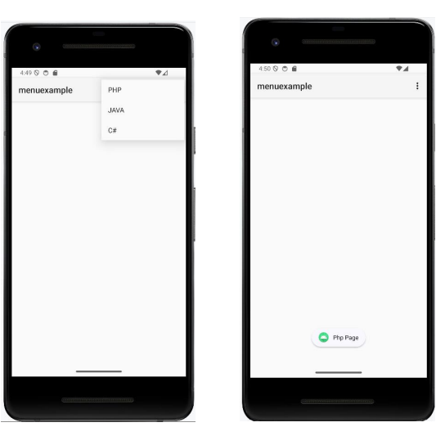

<?xml version="1.0" encoding="utf-8"?>  
<menu xmlns:android="http://schemas.android.com/apk/res/android">  
 <item android:id="@+id/php" android:title="@string/php"/>  
 <item android:id="@+id/java" android:title="@string/java"/>  
 <item android:id="@+id/csharp" android:title="@string/c"/>  
  
</menu>